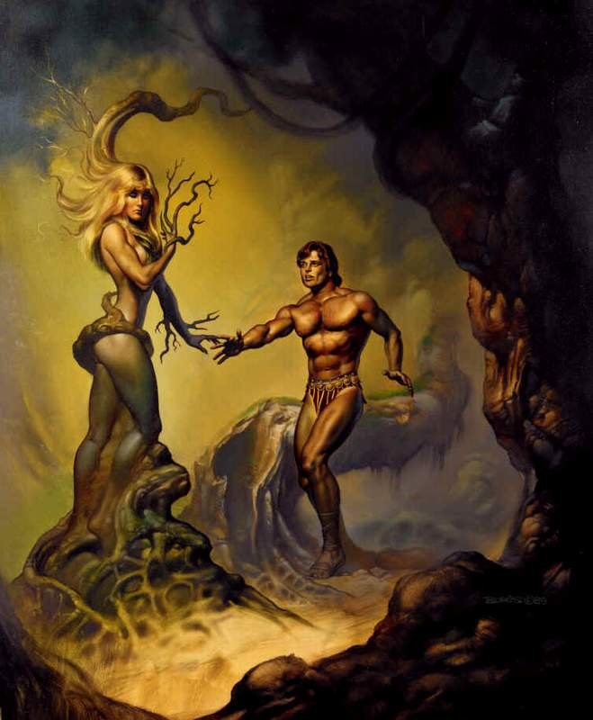
Origin and Lineage:

Daphne is a daughter of the River God, Peneus.

Interests:

Swimming, hunting, being a maiden.

Personality:

Daphne is like a tomboy, she loves being free and asks her father to never get married.

Most Famous Story:

To get revenge on Apollo, Eros struck him with an arrow to fall in love with Daphne, and struck Daphne with an arrow to repel love. As Apollo pursued Daphne, she begged her father to change her form, so that Apollo would not catch her. Peneus changed her to a Laurel tree. Even though she changed form, Apollo still loved Daphne, and so he claimed the Laurel leaf as his symbol. The Laurel wreath has since become a symbol for excellence.

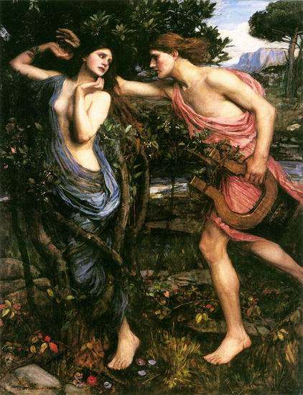
DAPHNE

Origin and Lineage:

Daphne is a daughter of the River God, Peneus.

Interests:

Swimming, hunting, being a maiden.

Personality:

Daphne is like a tomboy, she loves being free and asks her father to never get married.

Most Famous Story:

To get revenge on Apollo, Eros struck him with an arrow to fall in love with Daphne, and struck Daphne with an arrow to repel love. As Apollo pursued Daphne, she begged her father to change her form, so that Apollo would not catch her. Peneus changed her to a Laurel tree. Even though she changed form, Apollo still loved Daphne, and so he claimed the Laurel leaf as his symbol. The Laurel wreath has since become a symbol for excellence.

DAPHNE

Origin and Lineage:

Daphne is a daughter of the River God, Peneus.

Interests:

Swimming, hunting, being a maiden.

Personality:

Daphne is like a tomboy, she loves being free and asks her father to never get married.

Most Famous Story:

To get revenge on Apollo, Eros struck him with an arrow to fall in love with Daphne, and struck Daphne with an arrow to repel love. As Apollo pursued Daphne, she begged her father to change her form, so that Apollo would not catch her. Peneus changed her to a Laurel tree. Even though she changed form, Apollo still loved Daphne, and so he claimed the Laurel leaf as his symbol. The Laurel wreath has since become a symbol for excellence.

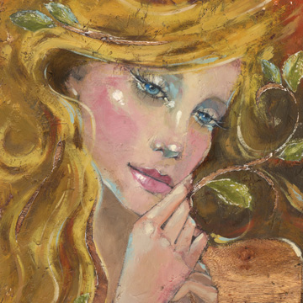
DAPHNE

Origin and Lineage:

Daphne is a daughter of the River God, Peneus.

Interests:

Swimming, hunting, being a maiden.

Personality:

Daphne is like a tomboy, she loves being free and asks her father to never get married.

Most Famous Story:

To get revenge on Apollo, Eros struck him with an arrow to fall in love with Daphne, and struck Daphne with an arrow to repel love. As Apollo pursued Daphne, she begged her father to change her form, so that Apollo would not catch her. Peneus changed her to a Laurel tree. Even though she changed form, Apollo still loved Daphne, and so he claimed the Laurel leaf as his symbol. The Laurel wreath has since become a symbol for excellence.

DAPHNE

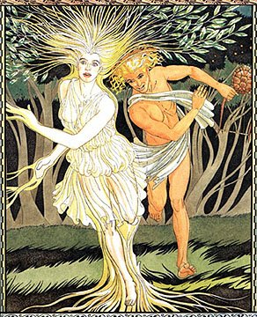
Works Cited:

Apollo & Daphne, by Giovanni Caselli
http://thanasis.com/apollo.htm

Greek Mythology Link by Carlos Parada. Online. Available: http://www.maicar.com/GML/Daphne1.html

Apollo and Daphne by John William Waterhouse. Online. Available:
http://www.artmall2000.com/art_products/art_large.asp?prodid=2689

Mythography. Online. Available: http://www.loggia.com/myth/daphne.html
© 2003 by Education World®. Education World grants users permission to reproduce this work sheet for educational purposes only.

The Story of Daphne from Daphne’s Greek Café:
http://www.daphnesgreekcafe.com/about%20us_story.htm

Daphne's beauty captivated all the gods.
Pursued by Apollo, Daphne was frightened.
For protection her father turned her into a laurel tree.
In her honor, Apollo created a wreath from her leaves.
The wreath, since called a Daphne, remains a symbol of excellence.

